User Management Use Case

Submitted to

Alpha Payments Cloud


Tarang Software Technologies Private Limited
Tarang Towers,
#400/2, Whitefield 100 ft road,
Hoody circle,
Bangalore, India
Phone: +91-80-41157777
WEB: www.tarangtech.com

© This document is exclusive property of Tarang software Technologies Private Limited. No part of this may reproduced in any form without written permission.

Document Change History

Ver# | Editor | Date | Reviewer | Approver | Changes made
0.1 | Sadanandh | 5th Sep 2012 | Bindu |  | Draft version
1.0 | Sadanandh | 7th Sep 2012 | Bindu |  | Base version
1.01 | Sadanandh | 17th Sep 2012 | Ronan |  | Updated with review comments
1.02 | Sadanandh | 21st Sep 2012 | Ronan |  | Updated the ADD/Edit use case with Entity ID field as input
Table of Contents
1 Introduction 4
2 Use Case: SEARCH Users 4
2.1 User Interface Information 5
2.1.1 User Interface details for search users 5
3 Use Case: Add USER 6
3.1 User Interface Information 7
3.1.1 User Interface details for Add User 7
4 Use Case: Edit USER 8
4.1 User Interface Information 9
4.1.1 User Interface details for Edit User 9
5 Use Case: View permissions 10
5.1 User Interface Information 10
5.1.1 User Interface details for View Permissions 10
6 Change Password 11
6.1 User Interface Information 12
6.1.1 User Interface details for Change Password 12
7 forgot Password 12
7.1 User Interface Information 13
7.1.1 User Interface details for Forgot Password 13

Introduction

This document describes all the use cases for User Management. It includes search Users, Add/Edit User, Change Password and Forgot Password.

Use Case: SEARCH Users

Title | Search Users
Requirement ID | RID-1031
Actors | System Admin, APC User with appropriate privilege to search users
Description | Actor should be able to search for the Users
Use case trigger | - When Actor selects the “Manage User” option from the main menu to search for the Users
Main flow / Flow of Events | - On choosing the “Manage Users “ option from the main menu, system shall display the list of recently created 20 users Page which shall include the search criteria’s:  User Name, Role, e-mail, Contact No, Hierarchy(Bank/ Corporate / Merchant), Country and Status  Action - Search  - Actor shall enter the search criteria & click on “Search” button.  - System shall build the query based on the criteria entered & retrieve the relevant records from the DB & display it in the listing in the below mentioned format:  [User Name, Role, e-mail, Contact No, Hierarchy, Country and Status].
Sub-flow/Alternate Flows/ Scenarios | 2a. If the actor does not choose to enter any data in the search criteria’s then the system shall retrieve all the user r records.  2b. If there are no relevant records for the search criteria chosen; system should display an appropriate message saying “No Records found.”  2c. Depending on the status criteria chosen, Active/Inactive only the users in the respective status should be retrieved.  3a. If the actor selects the row and clicks on edit link at the bottom of the table or double clicks on a selected row, system should navigate the actor to the corresponding user edit screen. This feature will be detailed as part of separate use case.  3b.If the actor clicks on the “Add User” link at the bottom of the table, system should navigate the actor to the Add user screen. This feature will be detailed as part of separate use case.  3c. If the actor selects the row and clicks on delete link at the bottom of the table, system should be able to remove the corresponding user from the system. This feature will be detailed as part of separate use case
Assumptions
Pre-conditions | Actor should be logged into the system & has the appropriate privilege to manage (add/edit or delete) users.
Post-conditions | - Actor is able to retrieve the relevant user records from the system based on the search criteria chosen.
Status | Open
Issues
Business Rules | Search – Query should be for partial search. I.e. like “%string%”. So the minimal search keys that you enter should retrieve the maximum information. For ex: Search By username – “Car” should retrieve all the users with the alphabet “car” in their names.

User Interface Information

User Interface details for search users

Refer Manage Users screen in story board

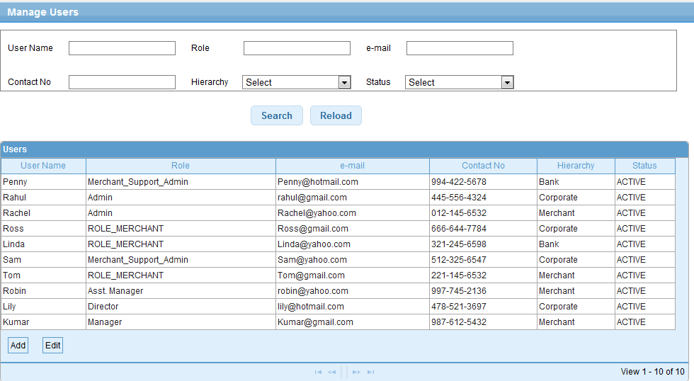

Validations for Search Users
Will be updated later
Id | Parameter Name | Field Type | Special characters | Validations | Field Length | Possible Values | Additional Condition | Mandatory
1 | User Name | Text Box
2 | Role | Text Box
3 | Email | Text Box
4 | Contact No | Text Box
5 | Country | Drop down
6 | Hierarchy | Drop down |  |  |  | Select, Bank, Corporate, Merchant
7 | Status | Drop Down

Use Case: Add USER

Title | Add User
Requirement ID | RID-1032
Actors | System Admin, APC User with appropriate privilege to Add users
Description | Allows the actor to add a user
Use case trigger | - Actor chooses to click on “Add User” link/button from the User listing screen (Manage Users)
Main flow / Flow of Events | - System shall navigate the actor to the Add User screen along with the following fields to be captured.  - details of the fields shown are:  - First Name*  - Last Name*  - User Name*  - Language*  - View Permissions  - Contact Number *  - Email Address*  - Address1 *  - Address 2  - Location/City  - State  - Country*  - Zip Code  - Role*  - Hierarchy  - Entity ID  * Mandatory fields  - Actor shall enter the relevant information & Click on Save.
Sub-flow/Alternate Flows/ Scenarios | 3a. If the user enters the invalid data, the system will navigate the actor to the same screen with appropriate error message.  3b. View Permissions – Actor can see the permissions of the Role in order to choose the suitable Role for the user.  Create Role – If the Actor doesn’t find the suitable role, actor can create a new Role  With set of permissions, based on the appropriate privilege assigned to the logged in user.
Assumptions | At least one Role exists in the system to associate the new user to a role
Pre-conditions | The actor is logged in to the application and has the permission to add user.
Post-conditions | - Add - New User will successfully be created in the system and the Actor will be navigated to the User listing screen with the newly created user details.  - Create New Role: New Role will be added to role drop down as selected one.
Status | Open
Issues | - What should be the sent from user email address for the automated email sent to  The new user. I will suggest support@gpcloud.com for now  - Email content to be finalized for the email notification.  - Identify the period duration for the expiry of the temporary password. I would suggest 7 days.
Business Rules | - An Email with login credentials will be sent to the user’s email id (given in the add user screen). There will be two emails that shall be sent to the new user. One email with the user id and login URL. The second email with the password.  - The first password set by the system will be temporary and this needs to be changed on login. This is to be mentioned in the email notification  - The temporary password should expire after a set/configured period of 7 days  - User should be able to log into the application and be able to do the operations the user has access permissions.  - Based on the hierarchy selected the respective entity Id in the APC system is listed in the Entity ID dropdown. For example if Bank is the hierarchy selected the Entity ID filed will list all the Bank ID of the APC system. If the user selects a Bank hierarchy level, then the bank level user can manage all the activities in the system for the selected bank based on the role permissions assigned, i.e. manage the bank, the corporate associated with the bank and the merchants associated with the selected bank.

User Interface Information

User Interface details for Add User

Refer Manage Users>> Add user screen in the story board

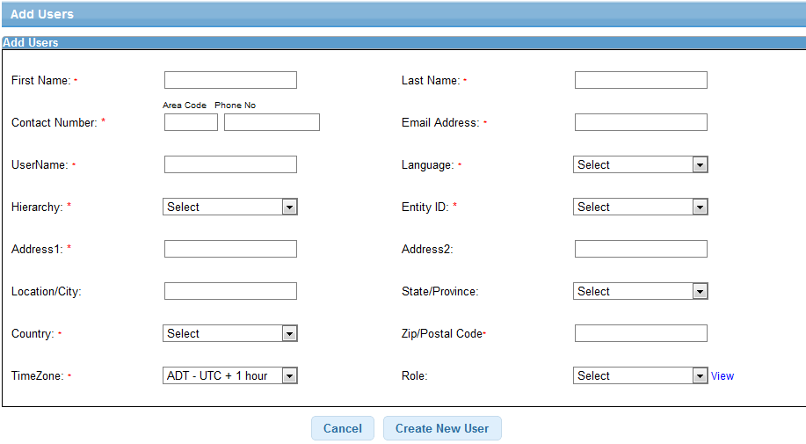

Validations for Add User

Id | Parameter Name | Field Type | Special characters | Validations | Field Length | Possible Values | Additional Condition | Mandatory
1 | First Name | Textbox | No | Alpha | 20 |  |  | Yes
2 | Last Name | Textbox | No | Alpha | 20 |  |  | Yes
3 | User Name | Textbox | No | Alpha | 20 |  |  | Yes
4 | Language | Drop down | N/A | N/A | N/A |  |  | Yes
5 | Contact Number | Textbox | No | Alpha Numeric | 20 | Specific to country | Only hyphen will be allowed | Yes
6 | Email Address | Textbox | No | Alpha Numeric | 75 |  |  | Yes
7 | Address 1 | Textbox | No | Alpha Numeric | 20 |  |  | Yes
7 | Address 2 | Textbox | No | Alpha Numeric | 20 |  |  | No
8 | Location/City | Textbox | No | Alpha | 20 |  |  | No
9 | Country | Drop down | No | Alpha | N/A |  |  | Yes
10 | State | Drop down | No | N/A | N/A | Specific to country |  | No
11 | Zip code | Textbox | No | Alpha numeric | 10 | Specific to country , with space also allowed |  | No
12 | Role | Drop down | N/A | N/A | N/A |  |  | Yes
13 | Hierarchy | Dropdown | N/A | N/A | N/A | Select/ Bank / Corporate/ Merchant |  | No
14 | Entity ID | Drop down | N/A | N/A | N/A |  |  | No

Use Case: Edit USER

Title | EDIT USER
Requirement ID | RID-1033
Actors | System Admin, APC User with appropriate privilege to Edit users
Description | Allows the Actor to Edit User details
Use case trigger | - Actor selects the row from the user listing grid and clicks on the Edit link at the bottom of the table or double click on the selected row
Main flow / Flow of Events | System shall navigate the actor to the Edit User screen along with the following fields to be updated.  details of the fields with the existing values shown are:  - First Name*  - Last Name*  - User Name* (Read only)  - Language*  - View Permissions  - Contact Number *  - Email Address*  - Address1 *  - Address 2  - Location/City  - State  - Country*  - Zip Code  - Role*  - Hierarchy  - Entity ID  - Status (Active /Inactive)  * Mandatory  Actor shall update the following one or more of the fields except Email ID and User Name fields and clicks on Edit button.
Sub-flow/Alternate Flows/ Scenarios | View Permissions – Actor can see the permissions of the Role in order to choose the suitable Role for the user.  Create Role – If the Actor doesn’t find the suitable role, actor can create a new Role  With set of permissions. This access is based on access permission for logged in user. This feature is a separate use case and is detailed as different use case
Assumptions | There exists at least one user in the system.
Pre-conditions | Actor is logged into the system & has the permissions to edit user.
Post-conditions | The fields which are modified will be updated in the DB and the Actor will be navigated to the User listing screen.
Status | Open
Issues | None
Business Rules | The Inactive user will not be able to login to APC  User name cannot be modified  The Format for Zip code, telephone should be based on the country selected.

User Interface Information

User Interface details for Edit User

Same as Add user screen of Storyboard

Validations for Edit User

Id | Parameter Name | Field Type | Special characters | Validations | Field Length | Possible Values | Additional Condition | Mandatory
1 | First Name | Textbox | No | Alpha | 20 |  |  | Yes
2 | Last Name | Textbox | No | Alpha | 20 |  |  | Yes
3 | User Name | Textbox | No | Alpha | 20 |  |  | Yes
4 | Language | Drop down | N/A | N/A | N/A |  |  | Yes
5 | Contact Number | Textbox | No | Alpha Numeric | 20 | Specific to country | Only hyphen will be allowed | Yes
6 | Email Address | Textbox | No | Alpha Numeric | 75 |  |  | Yes
7 | Address 1 | Textbox | No | Alpha Numeric | 20 |  |  | Yes
7 | Address 2 | Textbox | No | Alpha Numeric | 20 |  |  | No
8 | Location/City | Textbox | No | Alpha | 20 |  |  | No
9 | Country | Drop down | No | Alpha | N/A |  |  | Yes
10 | State | Drop down | No | N/A | N/A | Specific to country |  | No
11 | Zip code | Textbox | No | Alpha numeric | 10 | Specific to country , with space also allowed |  | No
12 | Role | Drop down | N/A | N/A | N/A |  |  | Yes
13 | Hierarchy | Dropdown | N/A | N/A | N/A | Select/ Bank / Corporate/ Merchant |  | No
14 | Entity ID | Drop down | N/A | N/A | N/A |  |  | No

Use Case: View permissions

Title | View Permissions
Requirement ID | RID-1034
Actors | System Admin, APC User with appropriate privilege to View Permissions
Description | Allows the actor to view the permissions of the Role
Use case trigger | - When the actor chooses to click on the “View permissions” link on the Manage Users >>Add/Edit User Screen
Main flow / Flow of Events | - Actor clicks on the View Permissions link on Add User screen.  - A pop-up screen will be displayed with all the permissions of the selected Role.  - Actor clicks on Close button on the pop-up  - The pop-up will be closed.
Sub-flow/Alternate Flows/ Scenarios | None
Assumptions | -
Pre-conditions | The actor is logged in to the application and selected the Role in Add/Edit User screen.
Post-conditions | None
Status | Open
Issues | -
Business Rules | View the Role permission for the selected role in the drop down

User Interface Information

User Interface details for View Permissions
Refer the Add user (view link) screen in the storyboard
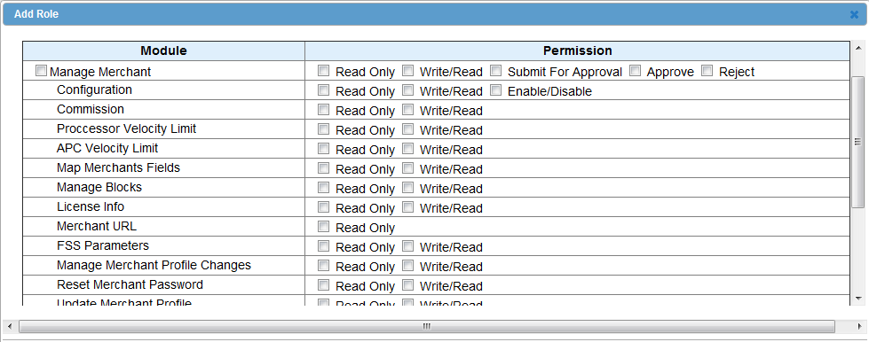

Validations for View Permissions
None

Change Password

Title | Change Password
Requirement ID | RID-1035
Actors | The logged in user
Description | Allows the Actor to Change the password
Use case trigger | Actor logs into the application and clicks on Change Password link  Or System Admin can select the user from user list and clicks on “Change password
Main flow / Flow of Events | System shall navigate the actor to the Change Password screen.  details of the fields with the existing values shown are:  - Old password  - New password  - Confirm Password  Actor enters the relevant fields and clicks on the Save button.
Sub-flow/Alternate Flows/ Scenarios | If the Actor enters the invalid data, system will navigate the user to the same screen with appropriate error message  If System Admin user select the user from the user list and click on the change password  This will trigger an email to the user with the temporary password
Assumptions | Actor logged into the system
Pre-conditions | Any Actor who is logged into the system
Post-conditions | The fields which are modified will be updated in the DB and the old password will become inactive and will be stored modified password history and the new password becomes active.
Status | Open
Issues | None
Business Rules | New Password and Confirm Password should be same.  New password should not be the same as 5 recent old passwords.  Password entered should be strong password with alpha numeric values  Password can also be reset by system admin user for different users if the user is inactive for some time and needs to be reset for accessing the system again.  Or if the temporary password expiry period has lapsed

User Interface Information

User Interface details for Change Password
Refer Change Password screen of storyboard

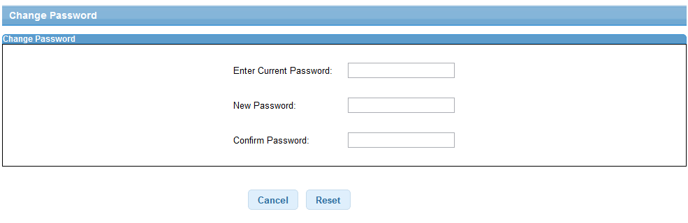

Validations for Change Password

Id | Parameter Name | Field Type | Special characters | Validations | Field Length | Possible Values | Additional Condition | Mandatory
1 | Current Password | Textbox | Yes | Alphanumeric | Min 6 Max 18 |  | Strong password | Yes
2 | New Password | Textbox | Yes | Alphanumeric | Min 6 Max 18 |  |  | Yes
3 | Confirm Password | Textbox | Yes | Alphanumeric | Min 6 Max 18 |  |  | Yes

forgot Password

Title | Forgot Password
Requirement ID | RID-1036
Actors | Any valid user who has registered with the system
Description | Allows the Actor to get the new password
Use case trigger | Actor clicks on the Forgot Password link on the Login screen.
Main flow / Flow of Events | - System shall navigate the actor to the Forgot Password screen.  details of the fields with the existing values shown are:  - Username  - Email Address  - Actor enters either of the relevant fields and clicks on the Submit button.
Sub-flow/Alternate Flows/ Scenarios | e  2a. If the Actor enters invalid data, the system will navigate the actor to the same screen  With appropriate error message.  2b. If the entered user name or email address does not match the records in the APC system, then a relevant error message “ Entered username or email address is invalid” is displayed
Assumptions | Actor is registered with the application
Pre-conditions | Actor is registered with APC
Post-conditions | The Actor will get the new password generated by the system to his e-mail address.
Status | Open
Issues | Error scenarios for invalid data
Business Rules | Actor has to give either username or email address  The given email address has to be matched with the email address captured during user registration.

User Interface Information

User Interface details for Forgot Password

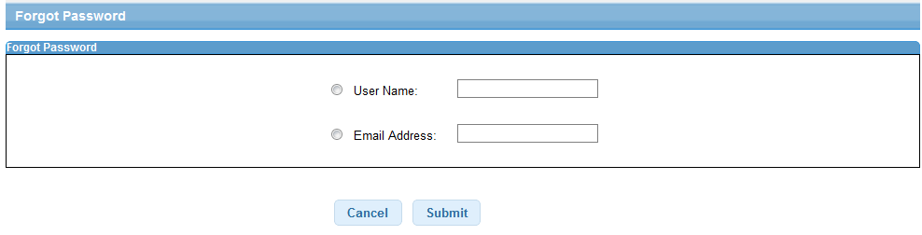

Validations for Forgot Password

Id | Parameter Name | Field Type | Special characters | Validations | Field Length | Possible Values | Additional Condition | Mandatory
1 | User Name | Textbox | Yes | Alphanumeric
2 | Email address | Textbox | Yes | Alphanumeric |  | Optional if username entered | Valid email id format

